Call for Abstracts

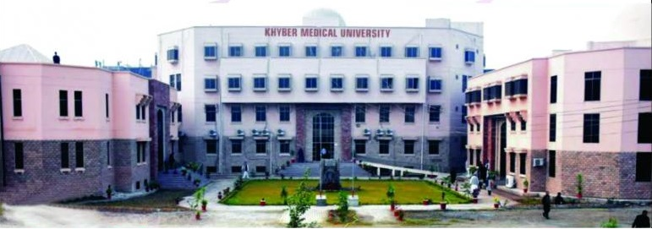The annual health research conferences organized by Khyber Medical University has become an important milestone in the academic calendar of the KP province. Once again, the university is going to organize its 9th International Annual Health Research Conference scheduled from March 5-7, 2018. The conference will include panel discussions, oral and poster presentations on topics in the fields of medical science (all specialties), dentistry, public health, nutrition, dietetics, environmental sciences and other activities to promote research culture among health professionals.
Objectives:
- Establish a forum for presentation, discussion and formulation of recommendations for issues in health research and health care in Pakistan generally and KP specifically.
- Disseminate findings of health research undertaken in KP in the last one year.
- Provide an opportunity to (young & emerging) researchers to develop the capacity for preparing and presenting health research papers.
- Establish a forum for dialogue with health research policy and decision –makers in Pakistan and KP.
- Establish links with expatriate Pakistani health professionals and researchers.
- Provide an opportunity for industry and academia interaction.

CALL FOR ABSTRACTS
Abstracts of intended presentations are invited for the 9th International Annual Health Research Conference of Khyber Medical University (KMU), Peshawar, scheduled from March 5-7, 2018.
Senior undergraduate and postgraduate students and TMOs and faculty are especially encouraged to participate. The conference will have dedicated sessions for oral presentations and arrangements for poster presentations to accommodate as many as possible. Model presentations have been included to motivate the undergraduate & postgraduate students to display their intellect.
Prizes will be awarded in the concluding session of the conference for the best oral, poster and model presentations.
Guidelines for Preparation of Abstracts
The abstract for oral and poster presentation should contain the following information on one single-sided A4 sheet. A font size of 12 point in time new roman should be used, with special characters and abbreviations avoided. A word count should not exceed 500.
Please submit structured abstracts in the following format:
- Title of the abstract
- Presenter(s), Author(s), affiliations (University/Department) and Address, email & contact No(s)
- Introduction – Foundation for research, Research question and objective(s) of the study
- Material and methods
- Results
- Conclusion
- Acknowledgements of Funding (if any)
How and where to Submit
The abstract may be submitted through email as attached MS Word file or a text file to the following addresses:
By Email ID: ahrc@kmu.edu.pk OR zeeshankibria@yahoo.com,
Subject on Email: Name of the presenter & title of the abstract
Deadline for Submission: February 10, 2018.
Your abstract may either be:
- Accepted for oral presentation. You will be informed of the session and time of presentation and the total time allowed for presentation;
- Accepted for Poster Presentation. The size of poster and venue will be communicated to you.
Abstract Status Notifications
Once an abstract has been received by the conference staff, the most efficient means of communication and notification of status will be by e-mail. Therefore, it is very important that a valid and current e-mail address be on record for all presenting authors to help speed the notification process.
It is important for the presenting author(s) to notify the Conference organizers with changes in e-mail addresses or other contact information.
The status of your abstract will be communicated to you by February 20, 2018 so that you have ample time for preparation of your oral and poster presentations.
For further information please contact: Office of Research Innovation & Commercialization, Khyber Medical University Peshawar. Contact No: 091 9217703, 091 9217258 Email: zeeshankibria@yahoo.com

