GUIDELINES FOR STUDENTS SELECTED FOR EUSP/EHSAS UNDERGRADUATE SCHOLARSHIP PROGRAM

- The students that were selected will have received an email from HEC/KMU.

- Those students will then click on the given link in the email and fill in the required boxes with the relevant information.
If an applicant has a B-form instead of a CNIC or is in possession of an expired CNIC then they must mention it in the given link.
The link is given below as well for ease of access:
nbp.hec.verify@gmail.com

If for some reason the email is not sent, then please try again and again as servers tend to be overloaded.

- National Bank of Pakistan (NBP) will then take the responsibility to set up an account for the applicant.

- The Deed Agreement, available on KMU’s website, is to be downloaded and filled as per the instructions given in the agreement. It must be printed on a stamp paper of a minimum amount.
The location of the agreement on the website is displayed below.
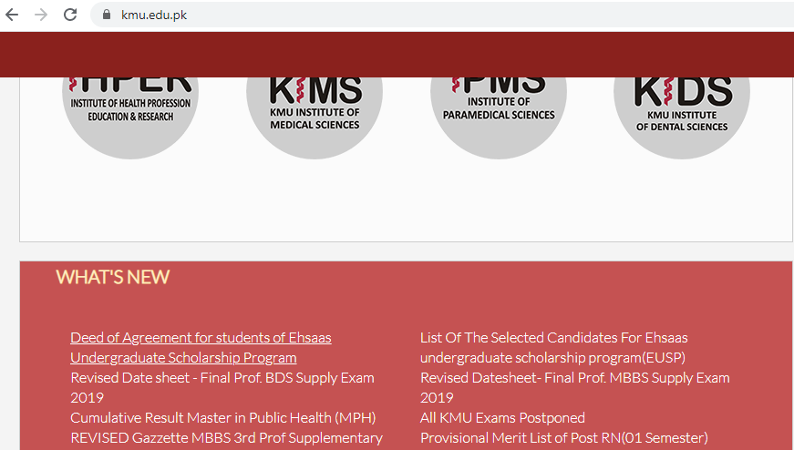

- Once the Deed Agreement has been printed and filled, it must be mailed by post on the given address on or before Friday, 26th June, 2020:

Department of ORIC,
Khyber Medical University,
Phase V, Hayatabad, Peshawar,
Khyber Pakhtunkhwa,
Pakistan

Please note that the agreement is to be sent by post. There is no need for the applicant to physically show up at the university to hand it in.

